Calculus I Midterm 1

Name: __________________ _____________________
(First NAME) (Last NAME)

Login _________________________ Signature: _______________________

1. (a) Draw an isosceles right triangle so that the equal sides have length 1 and label the hypotenuse with its length.

/1

(b) Use your picture in (a) and the CAST rule to determine the exact values of the following.

/2

2. State the period and find the range (show your steps) of
Period =

/2 Range =
3. (a) Solve the inequality. Give your answer using interval notation. (Use and CLEARLY label a NUMBER LINE ANALYSIS in your solution.)
/3

(b) What, in one sentence, is the essential difference between the question in 3(a) and solving ?
/1
(c) Solve the inequality. Give your answer using interval notation.
(Use and CLEARLY label a NUMBER LINE ANALYSIS in your solution.)
(HINT: Don’t you dare cross multiply!)
/4

4. (a) Solve the absolute value inequality. Give your answer using interval notation. (Use and CLEARLY label a NUMBER LINE ANALYSIS in your solution.)

/4

(b)
One of these MUST be solved by cases rather than squaring both sides. Which and give a reason why.
/1
5. Evaluate the following limits.
(a)
/2

(b)
/5

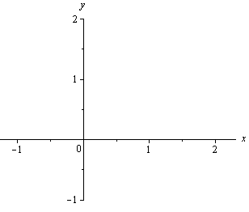Writewithout using “[[ ]]” notation, that is, write it as a “branch function”, and draw the graph.
/2

7. (a) Prove using theapproach:
Solution:

/3

(b) Prove using theapproach: .

/5

TWO CHOICES FOR QUESTION 8! Circle your choice.
8. Using the following triangle, prove 8. Using the following picture, prove
/5
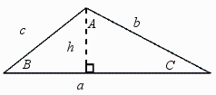

/2

